CPEG591-2026SP- Reinforcement Learning, Assignment #9

CPEG 591 – Assignment #9

Submitted by:
Shariar Islam Saimon
(Student ID: 1147129)



Department of Electrical/Computer Engineering
University of Bridgeport
Bridgeport, CT-06604
USA

Problem (1):
Output & Discussion:

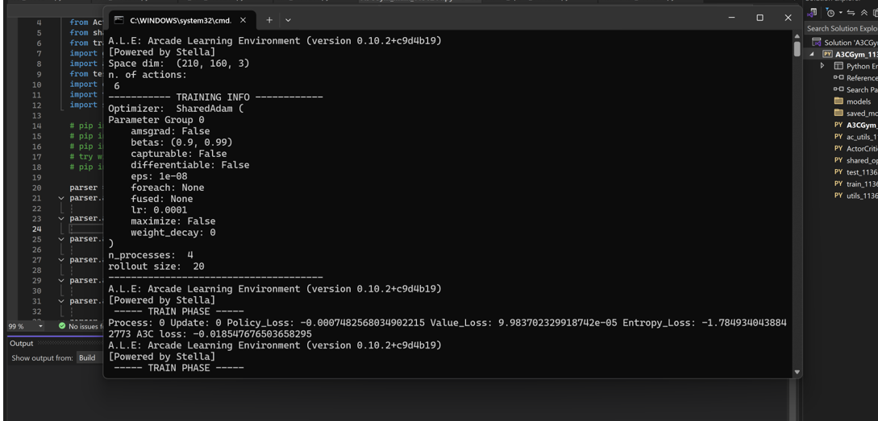

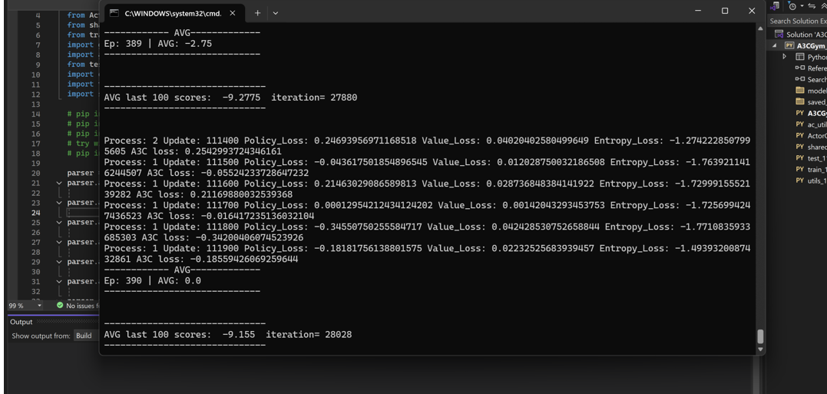

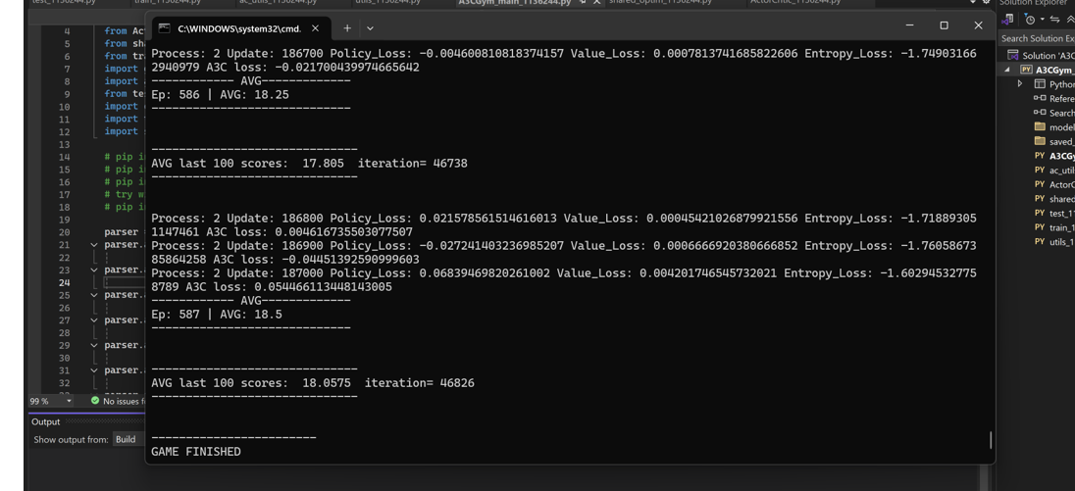
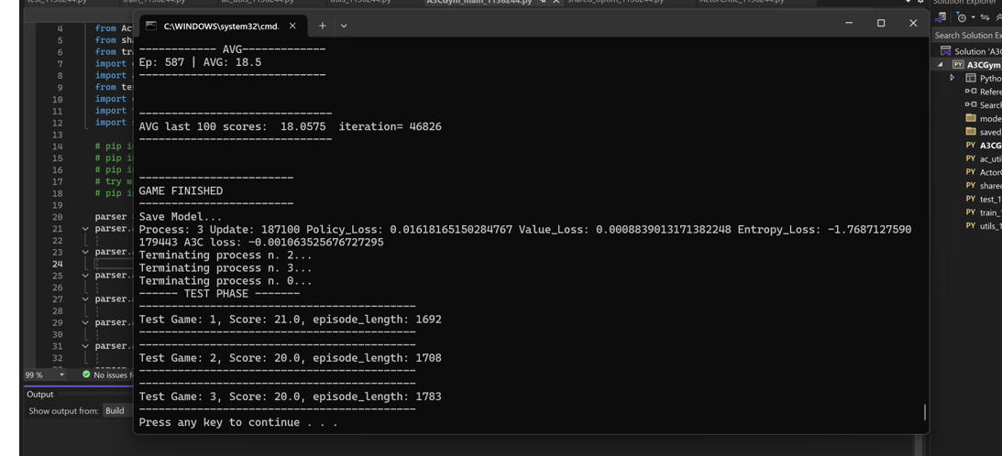
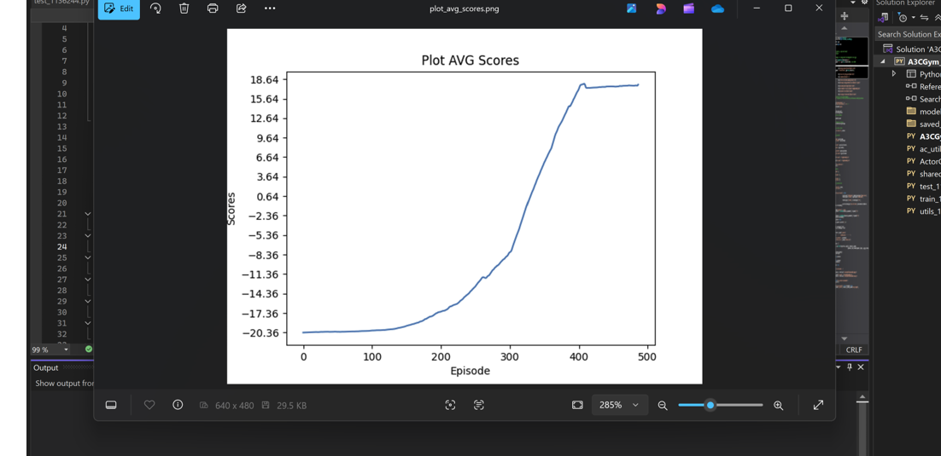
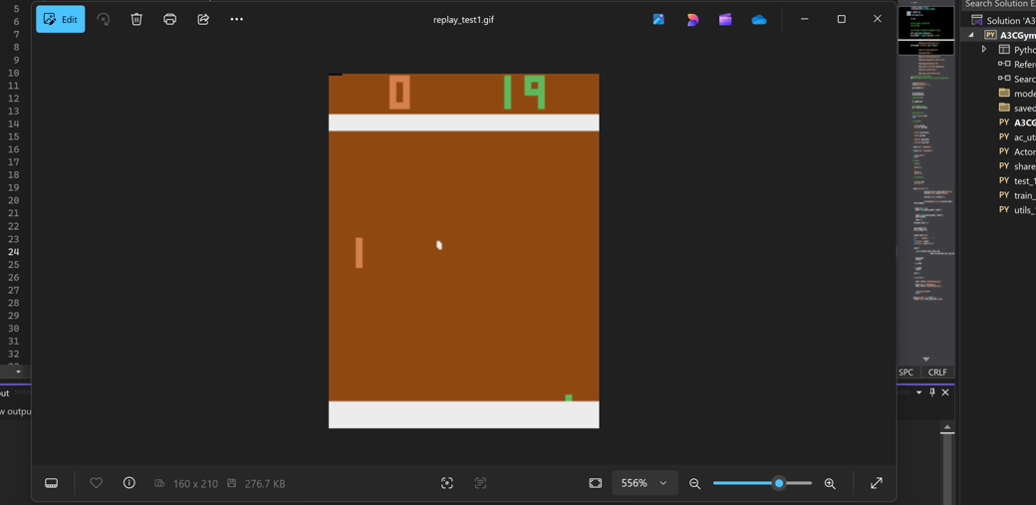
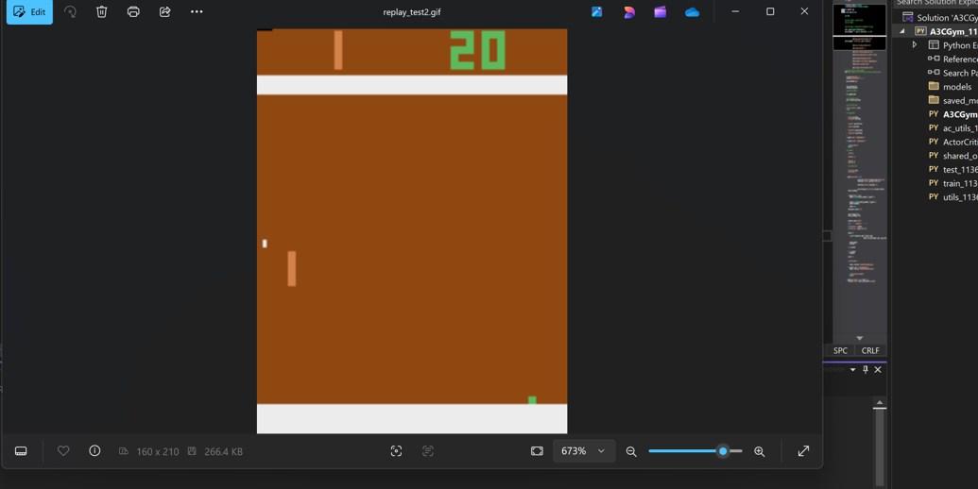
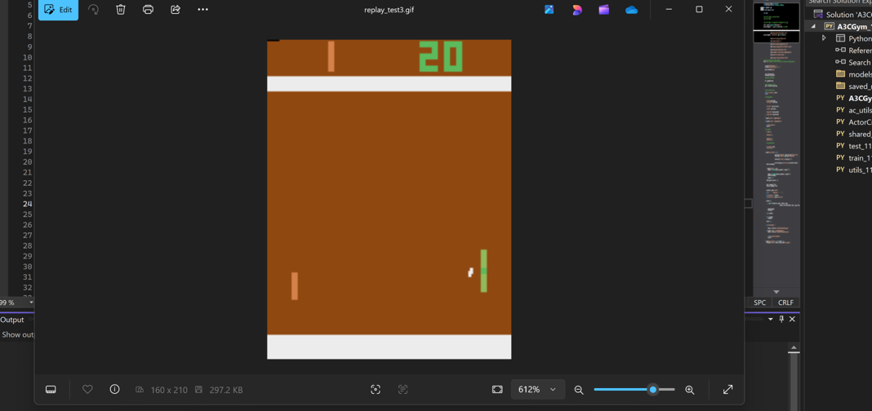
Discussions
- One key insight is that A2C can be seen as a synchronous version of A3C, where updates are done in a coordinated manner instead of asynchronously. This makes training more stable and easier to debug while still benefiting from reduced variance.
- The use of the advantage function (A = R − V(s)) not only reduces variance but also improves sample efficiency, meaning the agent learns better policies with fewer interactions compared to pure policy gradient methods.
- Another important observation is that the entropy term (if included) encourages exploration by preventing the policy from becoming too deterministic too early, which helps avoid local optima in reinforcement learning.
- A2C can be extended to more complex environments by integrating deep neural networks (CNNs or LSTMs), making it suitable for high-dimensional inputs such as images or sequential data. This shows its scalability beyond simple environments like CartPole.
- Compared to value-based methods like Q-learning, A2C directly optimizes the policy, which makes it more effective in continuous or large action spaces.
- Finally, this approach highlights the importance of bias-variance trade-off in reinforcement learning, where introducing a critic slightly increases bias but significantly reduces variance, leading to overall better performance.

From this assignment, I also observed that A2C provides more stable learning compared to REINFORCE. Because the value function reduces variance, the reward curve is generally less noisy and the agent learns a good balancing policy faster. Overall, this assignment helped me better understand actor-critic methods, the role of the advantage function, and why combining policy learning with value estimation can improve reinforcement learning performance.

